**Topic #6:**

**Behavior of Gases &**

**Gas Laws**

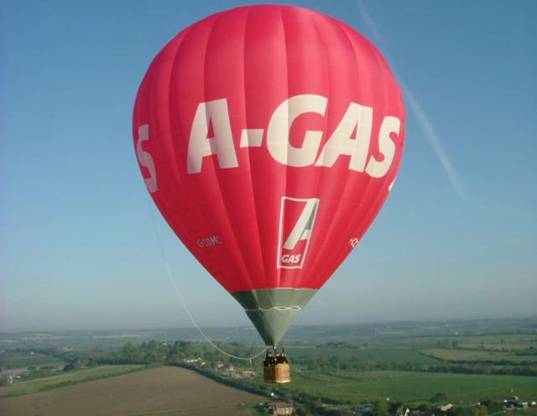

Textbook Chapters 13 & 14

(pg. 420-424; pg. 448-485)

**Homework Due:** Wednesday, December 9

**Exam - Free Response:** Friday, December 11

**Exam - Multiple Choice:** Monday, December 14

Student Study Guide: Topic #6 - Behavior of Gases and Gas Laws

Temperature

* Temperature is a measure of the average kinetic energy of the particles.
* Common temperature scales include Celsius and Kelvin (or Absolute).
  + Kelvin is used in all Gas Laws formulas because temperatures on the Kelvin scale are directly proportional to the average kinetic energy of the particles. Celsius temperatures are not.
* Absolute zero (0 Kelvin) is the theoretical temperature at which no molecular motion exists.

Vapor pressure

* Vapor pressure is defined as the pressure exerted by a gas over its liquid or solid phase.
* Vapor pressure is dependent only on temperature (see Chart H) (*not* pressure, amount of substance present, etc.)
* Substances with weak intermolecular forces of attraction (IMFA) have high vapor pressures, and evaporate easily. Substances that evaporate easily are called *volatile*.
* Substances with strong IMFA have low vapor pressures and do *not*  evaporate easily since these attractive forces must be overcome to form the gas phase.

Standard Temperature and Pressure (Reference Table A)

* STP is defined as:
  + Temperature: 0oC or 273K
  + Pressure:
    - 1 atmosphere (atm)
    - 101.3 kilopascals (kPa)
    - 760 torrences (torr)
    - 760 millimeters of mercury (mmHg)

Kinetic Molecular Theory of Gases

1. Gases consist of tiny particles (atoms or molecules).
2. These particles are extremely small compared with the distances between them; the volume (size) of individual particles can be assumed to be negligible (zero).
3. Gas particles are in constant, random motion, colliding with the walls of their container. These collisions with the walls cause the pressure exerted by the gas. Collisions result in a transfer of energy although the average kinetic energy does not change as long as the temperature is constant (i.e., collisions are said to be "elastic.")
4. Gas particles are assumed not to attract or repel each other.
5. The average kinetic energy of the gas particles is directly proportional to the Kelvin temperature of the gas.

Gas Laws (check schematic diagram included in the study guide)

BOYLE CHARLES GAY-LUSSAC AVOGADRO

P x V = k V/T = k P/T = k V/moles = k

inverse direct direct direct

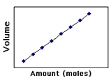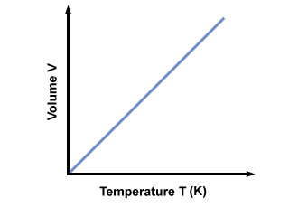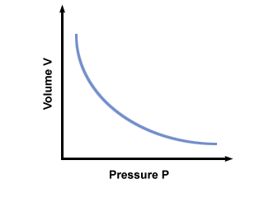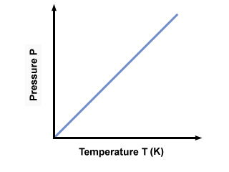

Graham’s Law of Diffusion

* Graham's Law of Diffusion states that the rate of diffusion of a gas has an inverse relationship to the mass or density of the gas.
* The *greater the mass* or density of the gas, the *slower* the gas will diffuse.
* The lower the mass or density of a gas the faster the gas will diffuse.

Calculating Density of a Gas:

* Density (g/L) = molar mass(g) / 22.4 (L)

Dalton’s Law of Partial Pressure

* Dalton's Law of Partial Pressure states that for a mixture of gases in a container, the total pressure exerted is the sum of the partial pressures of the gases present.
* Partial pressure of a gas is the pressure that the gas would exert if it were alone in the container.
* Ptotal = P1 + P2 + P3  .........
* Total pressure / total moles = pressure per mole

Combined Gas Law (Reference Table T)



* By removing the factor that is constant a formula is obtained to solve for either Boyle, Charles or Gay-Lussac’s Law.

Ideal Gas Law

* By combining the laws of Boyle, Charles and Avogadro, we can show how the volume of a gas depends on pressure, temperature and number of moles present.
* Ideal Gas Law equation: PV = nRT

P = pressure V = volume n = number of moles R = universal gas constant (0.08206 L atm / K mol) and T = temperature in Kelvin

* A gas that obeys this equation is said to behave ideally under conditions of high temperature, low pressure and low mass when particles do not attract or collide.

KEY VOCABULARY

STP vapor pressure temperature

absolute zero Kelvin Celsius

density real gas ideal gas

collision direct relationship inverse relationship

diffusion partial pressure Kinetic Molecular Theory

Ideal Gas Law

Combined Gas Law

Boyle’s Law

Charles’ Law

Gay-Lussac’s Law

Avogadro’s Law

Graham’s Law of Diffusion

Dalton’s Law of Partial Pressure

**STUDENT HOMEWORK PACKET**

Topic #6: Behavior of Gases & Gas Laws

**Section A – Kinetic Molecular Theory (KMT) and Properties of Gases**

1. Use your textbook to state the three assumptions of the kinetic theory as it applies to gases (pg. 420).

a) The particles in a gas are considered to be small, hard spheres with an insignificant volume.

b) The motion of the particles in a gas is rapid, constant, and random.

c) All collisions between particles are perfectly elastic.

2. Define “gas pressure” (pg. 421).

Gas pressure is the result of billions of rapidly moving particles in a gas simultaneously colliding with an object.

3. Describe the relationship between atmospheric pressure and altitude. Explain.

Atmospheric pressure decreases as you climb a mountain because the density of Earth's atmosphere decreases as the elevation increases.

4. Complete the following pressure conversions. SHOW ALL WORK.

a) Convert 385 mmHg to atmospheres.

.507 atm

b) Convert 385 mmHg to kilopascals.

51.3 kPa

c) Convert 3.2 atmospheres to kilopascals.

324. kPa

Textbook Page 454:

#1: Gases are easily compressed because of the great amount of space between gas particles.

#2: temperature, volume, and amount of gas

#3: Because the gas in the inflated air bag can be compressed, the bag absorbs some of the energy from the impact of a collision. The solid steering wheel cannot do this.

#4: If the temperature decreases, the pressure will also decrease.

Textbook Page 463:

#17: At constant temperature, volume decreases as pressure increases.

#18: At constant pressure, volume increases as temperature increases.

#19: At constant volume, pressure increases as temperature increases.

#22: 24.2 L

**Section B - Combined Gas Law Calculations**

**Instructions**: Complete the following problems. For each problem, state the name of the law used and show all work, including correct formula, substitution with units and final answer with proper units. Put a box around your final answer.

1. Submarines need to be strong to withstand the extremely high pressure of water pushing down on them. An experimental research submarine with a volume of 15,000 liters has an internal pressure of 1.2 atm. If the pressure of the ocean breaks the submarine forming a bubble with a pressure of 250 atm pushing on it, how big will that bubble be? Assume temperature is constant.

Name of Law Boyle's Law

P1V1 = P2V2

(1.2 atm)(15,000 L) = (250 atm)(V2)

V2 = 72 L

1. The temperature inside a refrigerator is about 4.0o C. If a balloon with an initial temperature of 22o C and a volume of 6.5 liters was placed into the refrigerator, what will the volume be when the balloon is completely cooled to the internal temperature assuming the pressure is constant.

Name of Law Charles' Law

V1 / T1 = V2 / T2

6.5 L / 295 K = V2 / 277 K

V2 = 6.1 L

1. An aerosol can at room temperature (25oC) contains gas under 2.3 atm of pressure. The can was left in the sun for 2 hours and reached a temperature of 55oC. What is the new pressure inside the can. The volume of the can does not change.

Name of Law Gay-Lussac's Law

P1 / T1 = P2 / T2

2.3 atm / 298 K) = P2 / 328 K

P2 = 2.5 atm

Explain why there is “CAUTION” not to exceed 55oC temperature on all aerosol cans.

With an increase in temperature, there is an increase in pressure due to increased collisions with the sides of the container. This may cause the can to explode.

4. An unknown volume of a gas has a pressure of 52.5 kPa and a temperature of 325 K. The pressure is raised to 121 kPa, the temperature is decreased to 320 K and the final volume of the gas was computed to be 48.0 L. What was the initial volume of the gas?

Prediction:

* The change in temperature from 325 K to 320 K will cause the volume of the gas to decrease (increase or decrease).
* The change in pressure from 52.5 kPa to 121 kPa will cause the volume of the gas to decrease (increase or decrease).

Calculation using Combined Gas Law:

P1 V1/ T1 = P2 V2/ T2

52.5 kPa (V1) / 325 K = (121 kPa)(48.0 L) / 328 K

V1 = 112 L

Does your answer make sense with your prediction? Yes; the volume decreased from 112 L to 48.0 L.

Textbook Page 480:

#56: 18 L

#60: 1.10 x 103 kPa

Textbook Page 481:

#79: The pressure will double.

#80: Temperatures measured on the Kelvin scale are directly proportional to the average kinetic energy of the particles. Celsius temperatures are not.

#81: The water boils at a higher temperature, which speeds the cooking process.

**Section B – Vapor Pressure of Four Liquids (Reference Table H)**

1. What is the vapor pressure of ethanol at 75oC? 85 kPa

1. At what temperature is the vapor pressure of water 101.3 kPa? 100oC (normal boiling pt)
2. Identify the substance that has the strongest intermolecular forces of attraction.

Ethanoic acid

4. Explain how the boiling point temperature is affected as the atmospheric pressure of a substance increases.

As atmospheric pressure increases, the boiling point temperature increases because more kinetic energy is needed to overcome the increased pressure on the surface of the liquid.

5. Describe why the vapor pressure of a liquid changes with an increase in temperature.

As the temperature increases, the vapor pressure increases because more particles obtain enough kinetic energy to evaporate and form more gas molecules above the liquid. More gas molecules exert more vapor pressure.

**Section C – The Ideal Gas Law**

Ideal Gas Law

1. According to section 13.5 on page 415, what characteristics of a gas does the Ideal Gas Law involve?

The law involves the pressure, volume, temperature, and number of moles of gas.

1. The formula for the Ideal Gas Law is PV = nRT. What does each stand for?

P = pressure n = number of moles of gas V = volume

R = universal gas constant (0.08206 L atm / K mol) T = temperature

1. This equation defines the behavior of an ideal gas. What does “ideal” refer to?

An ideal gas is a gas with low mass at high temperature and low pressure. An ideal gas obeys the Ideal Gas Law exactly. "Ideal Gases" don't really exist, but provide a model for us to base our calculations off of.

Textbook Page 468:

#31: Real gases deviate from ideal behavior at low temperatures and high pressure.

#32: 17.0 L

#33: 4.48 kg

#34: An ideal gas obeys the assumptions of kinetic theory. A real gas deviates from ideal behavior except within a small range of conditions.

Textbook Page 480:

#63: Its particles have no volume, there are no attractions between them, and collisions are elastic. An ideal gas follows the gas laws at all temperatures and pressures.

**Section E – Dalton’s Law of Partial Pressures & Graham’s Law of Diffusion**

1. Suppose you have two 1-L flasks, one containing N2 at STP, the other containing CH4 at STP. How do these systems compare with respect to the following:

**Assume same V, P, an T.**

1. number of molecules: The number of molecules is qual, according to Avogadro's Law.

B) density: N­2 has greater density, according to the calculations below:

N2: d = 28 g/22.4 L = 1.25 g/L

CH4: d = 16 g/22.4 L = 0.714 g /L

1. average kinetic energy of the molecules: The molecules have the same kinetic energy, as the temperature (average kinetic energy) is the same.
2. rate of diffusion through a pinhole: Since the density of N2 is greater, N2 has a slower rate of diffusion according to Graham's Law of Diffusion.

2. A) A 2.0 liter sample of oxygen gas is saturated with water vapor at 27oC. The total pressure of the mixture is 772 torr, and the vapor pressure of water is 26.7 torr at this temperature. What is the partial pressure of the oxygen gas?

P1 + P2 + P3... = Ptotal

772 torr = 26.7 torr + P2

P2 = 745.3 torr

B) Name of Law: Dalton’s Law of Partial Pressures

1. What is the pressure of the oxygen gas in atmospheres?

745.3 torr of O2 x 1atm/760 torr = 0.98 atm

D) Using the **Ideal Gas Law**, how many moles of oxygen are there in the sample of oxygen?

PV = nRT

n = PV/RT

n = (0.98 atm)(2.0 L)/(.08205 L atm / K mol)(300 K)

n = 0.796 mol

Textbook Page 474:

#40: Total pressure is equal to the sum of the partial pressures of the components.

#41: Gases with lower molar masses diffuse and effuse faster than gases with higher molar masses.

#43: 191.3 kPa

#45: Carbon monoxide and nitrogen have identical molar masses when the masses are rounded to two significant figures (28 g).

Textbook Page 481:

#89: Ammonia diffuses faster than hydrogen chloride. Based on the location of the reaction product, the ammonia molecules travel about twice the distance of the hydrogen chloride molecules in the same time.

**Pearson SuccessNet On-Line**

**1. Go to: Chapter 14 🡪 Chapter-Level Activities 🡪 Ch. 14 A Fresh Look At Fruit 🡪 Watch Video.**

**2. Go to: Chapter 14 🡪 Chapter-Level Activities 🡪 14.4 Kinetic Art: Partial Pressure of Gases. Answer all questions and submit.**

**Reading in the Sciences Assignment**